OFFICIAL LEAGUE ROSTER - SOCCER

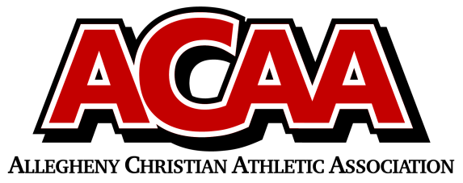

School Name: GREAT COMMISSION SCHOOLS

Team Colors: ROYAL BLUE AND WHITE

Overall Wins ___ Losses ____ Ties ___

ACAA Wins ___ Losses ____ Ties ___ OPPONENT: __________________________

DATE: _________

| **Number** | **Name** | **Year** | **Position** | **Homeschool** |
| --- | --- | --- | --- | --- |
| 4 | Daniel Kurty** | 12 |  |  |
| 15 | Keith Biddle | 12 |  |  |
| 5 | Aaron Kurty** | 11 |  |  |
| 19 | Wesley Hicks** | 11 |  |  |
| 13 | Ian Grissinger | 11 |  |  |
| 6 | Van Nachtman** | 11 |  | YES |
| 12 | Donovan Bickings | 10 |  |  |
| 10 | Owen Huber | 10 |  | YES |
| 11/1 | Joel Lohsl | 9 |  |  |
| 7 | Blake Nachtman | 9 |  | YES |
| 22/35 | Isaiah Eichelberger | 9 |  |  |
| 3 | David Wolford | 9 |  |  |
| 17 | Josiah Mauk | 8 |  |  |
| 9 | Joseph Mauk | 7 |  |  |
| 16 | Luke Stachmus | 7 |  |  |
| 20 | Jared Edouard | 7 |  |  |
|  |  |  |  |  |
|  |  |  |  |  |
|  |  |  |  |  |
|  |  |  |  |  |
|  | **Denotes Team Captains |  |  |  |
|  |  |  |  |  |
|  |  |  |  |  |
|  |  |  |  |  |
|  |  |  |  |  |

Head Coach: Jason Mauk

Asst. coach: Kevin Bickings

Asst. coach: Julie Lohsl

Asst. coach: [**Owen Hildebrand**](mailto:ohildebrand22@gmail.com)

Official ACAA League Team Roster. to be submitted to the scorer’s table before each game.